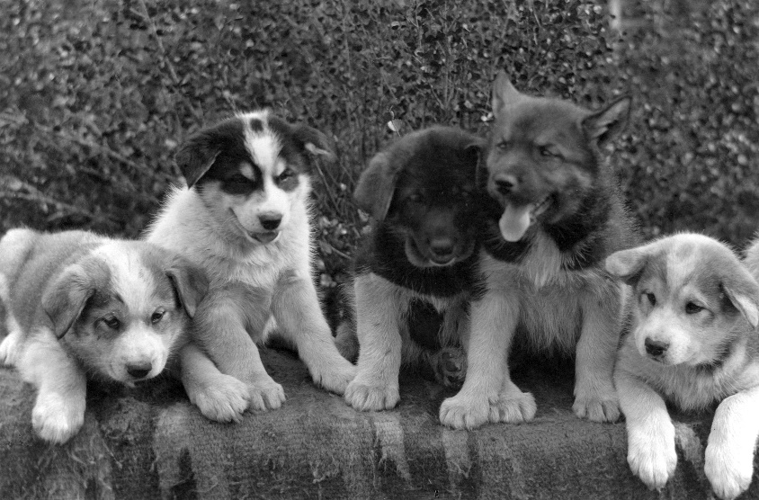
Theme: Dogs
Activity 1: Research your favourite breed of dog and write three facts about it.
Activity 2: Draw a picture of your favourite dog/s. It might be a family pet, a dog from a television programme or simply a favourite breed. Draw a picture of the dog, label the drawing and write a few sentences about the picture. The junior classes could write three or four sentences and the senior classes could write a paragraph or two.
Activity 3: Design a leaflet for a vet clinic, outlining advice for responsible pet ownership eg. It is important to get your pet dog vaccinated etc. Make the leaflet nice and colourful so it catches the eye of the clients entering the clinic.
Activity 4: Draw a vet clinic scene. Label the animals in the clinic. Older pupil can write a paragraph describing what is in the scene. E.g. why are the animals in the vet clinic? Were they sick? Injured? How is their owner feeling?
Activity 5: Research working dogs. Name 3 different breeds of dog which are working dogs. Pick one and write five facts about the dogs work.
Activity 6: Make a garden for a dog out of Lego or playdough.
Activity 7: Go for a walk in your neighbourhood with your family and see if you can spot any dogs Count how many you see and draw a picture of the dogs when you get home.
Activity 8: My dream pet: draw a picture of your dream pet. Older pupils can write about their dream pet including a description of the pet and the activities they would do the pet and the care they would take of the pet.

